http://oldtown.glendon.yorku.ca/~teaching/bohemian/mp3/
Credits to Fred Mercury
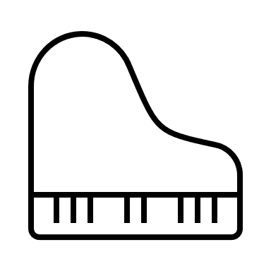Mix down of XXXX | mixdown.mp3
 | piano.mp3
 | vocals_ballad_addition.mp3
 | vocals_ballad_part.mp3
 | vocals_count_in.mp3
 | vocals_end.mp3
 | vocals_intro.mp3
 | vocals_ohfkit.mp3
 | vocals_rockppart.mp3

