Your name: __________________________________

Itec/MODR 2635 EN
Fall 2022

Homework 1: Glendon working environment & Introduction to Web and Advanced 365



Submission link.

Due: Thursday, October 13
at midnight

Moodle: https://eclass.yorku.ca

Rstudio-server: https://oldtown.glendon.yorku.ca/
Username: yourlastname (always in small letters)
Password: your_student_number

Your web pages URL are at: http://oldtown.glendon.yorku.ca/~yourlastname

You will have next this graphic, or graphical user interface (GUI) below:

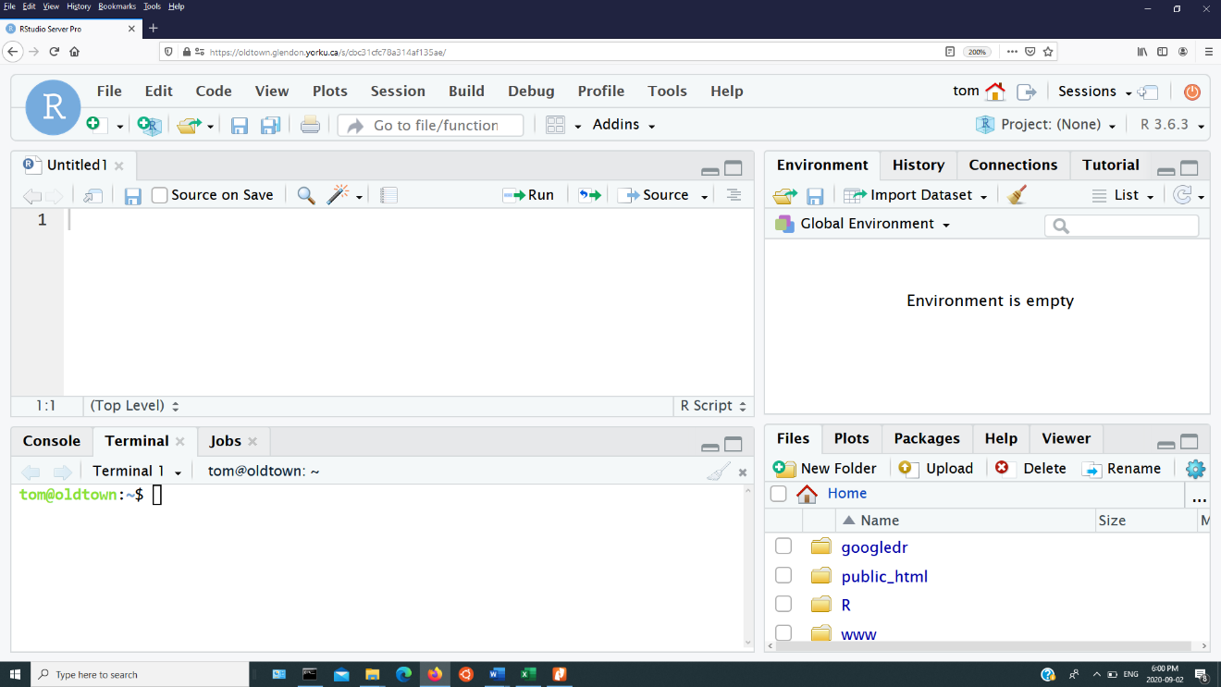

Your web files are in /home/yourlastname/www, once you have logged in.

- WORD office 365 and SWAY:

- How would you “transform” this WORD document into a sway interactive presentation (with references and cross-references) just like the one here:

http://oldtown.glendon.yorku.ca/~sandy01/itec2635/homework1/sway/sway02.html

- Command line or CLI.

- View and practice each of the CLI given in this video: (nothing to hand in)

http://oldtown.glendon.yorku.ca/~teaching/2021/l1/ex004.mp4

Click on “terminal” to activate that console in order to type command line (CLI), followed by “return” key. So we are giving a command to the computer (operating system) by typing a text (a keyword); more on Human–computer interaction.

Utility | Description
ls | "list" files and directories
pwd | "print working directory"
cd | "change (your working) directory"
mkdir | "make directory"
rmdir | "remove directory"
cp | "copy" a file or directory
mv | "move" a file or directory (i.e., rename it)
rm | "remove" a file (i.e., delete it)

Displaying Text Files
It is often convenient to look at the contents of a text file without having to open it in an editor. Previously in this lab, we saw that cat can be used for this purpose, but it is most useful for short files that can be viewed all on one screen.
GNU/Linux provides several other utilities that are useful for "paging" through text files (i.e., for viewing files one page at a time). Several of these commands are outlined in the following table.
Command | Description
more | move through a file screen by screen (hit space for the next page, return for one more line)
- Answer (fill in the blank) 1-10, below. The CLI should be executed sequentially.

# | Operation | What is the Command?
1 | list files & directories.
2 | Put yourself at the HOME directory
3 | make a sub-directory called “myfile” in the home directory.
4 | Put yourself at the PATH /home/lastname/myfile
5 | Show your current PATH
6 | show the path for where you are in the directory.
7 | Make a subdirectory at /home/lastname/www/myfile/mp3
8 | list the contents of the home directory, no matter where you are.
9 | Put yourself at ~/myfile/mp3
10 | Put yourself at your home directory again
11
12
13
14
15
16
17
18
19
20

- Can you make an account at https://trinket.io/?

- Next, read and practice at the given link below: (nothing to hand in)

https://docs.trinket.io/getting-started-with-html#/html/a-basic-webpage
https://docs.trinket.io/getting-started-with-html#/html/adding-elements
https://docs.trinket.io/getting-started-with-html#/html/styling-with-attributes
https://www.w3schools.com/tags/tag_video.asp
https://www.w3schools.com/html/html_lists.asp
https://www.w3schools.com/html/html_images.asp

- The following link give some videos:

http://oldtown.glendon.yorku.ca/~sandy01/music/videos/

Make a URL at your site:

http://oldtown.glendon.yorku.ca/~lastname/music/french/brel01.html

that behaves and looks exactly like this page:

https://politicalrights2022-1223.trinket.io/sites/q01-html

Note that I have “disguised” the html source code at the link above.

- Can you make your own web page at http://oldtown.glendon.yorku.ca/~lastname/itec2915/lect1/dog.html
that looks just like this one:

https://politicalrights2022-1223.trinket.io/sites/q04-html
Note that I have “disguised” the html source code at the link above.

- Can you make your own web page at http://oldtown.glendon.yorku.ca/~lastname/2635//imagine/ex5.htm
that looks just like this one:
https://politicalrights2022-1223.trinket.io/sites/q05-html

- Create the hierarchical organization for your webpage at Glendon which includes the following structure:

- Protect your web page at the URL:

http://oldtown.glendon.yorku.ca/~yourlastname/itec2635/q6/homework1

with multiple, distinct usernames: “yourlastname01”, “yourlastname02”, “yourlastname03”, but the password is the same. It is your student number.

HINTS: Here is a recorded example

Link to class recording:
https://yorku.zoom.us/rec/share/xQwG5PTHoYWHMoZlH4cGcgfOvHmoO4KjI71SumGo8FuGg7bbTD824wSh9vfKOB6T.Hn5_fjuhSvPGpdqT?startTime=1663951565000
https://yorku.zoom.us/rec/share/EdDwEi1BGbpgDz2r9hK8yrSs0qgNx2jZ9l4xoec2znHmaHcnWaWkr39TDJZm9Tsp.uqb69ptclPYLt55_
The link below gives you the video recording for the question on
web security. I said clearly in the video that I deliberately made the
mistakes and next corrected them so that you may gain some experience.
They are "wilful" mistakes to help you, at 5:12 and 5:37 minutes.

Summary:
-- 0:32 We wish to protect the URL:
http://oldtown.glendon.yorku.ca/~sandy01/itec2915/2/homework1
with a username “tintin1” and a password “glendon” at minutes 7:08
-- from minutes 7:44 forward, we set up distinct, multiple
usernames and passwords.
*** You will see the similar questions in homework and tests, see also lecture notes on web security ***
Please practice.

THE END

- If an element has flex: 1 , this means the size of all of the other elements will have the same width as their content, but the element with flex: 1 will have the remaining full space given to it.

