Contents

Itec/MODR 2635 Notes on Video Processing 1

A. Video codec 3

You can select a video codec and apply “Filters”. 3

B. Resolution 3

C. The “Configure” option 5

Notes on Video Processing

[Avidemux](http://avidemux.sourceforge.net/) is a free video editor designed for simple cutting, filtering, and encoding tasks.

[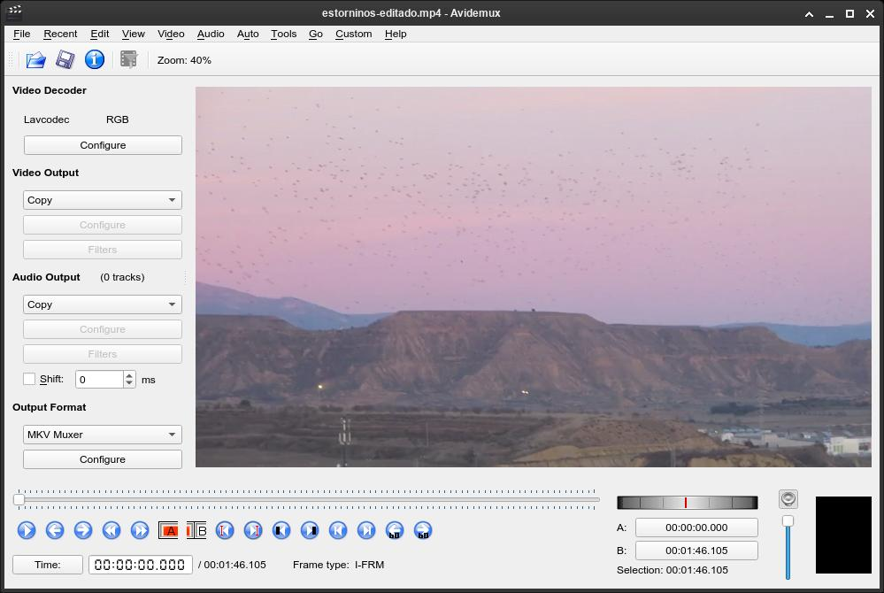](https://rs1.es/assets/imgs/avidemux-1.jpg)

You can cut videos using the “A” and “B” buttons to set the start and end of the video, and you can do it without re-encoding by selecting “Copy” under “Video Output” and “Audio Output”.

# Video codec

## You can select a video codec and apply “Filters”.

[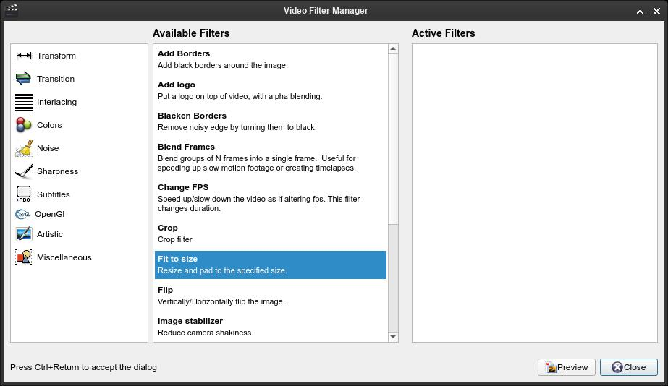](https://rs1.es/assets/imgs/avidemux-2.jpg)

# Resolution

* Change resolution (“Fit to size”).
* Add a “Fade in” or “Fade out” (add fade duration in “Manual time entry” and select one of the fade types, the most used for video start and ending is “Color blend”).
* [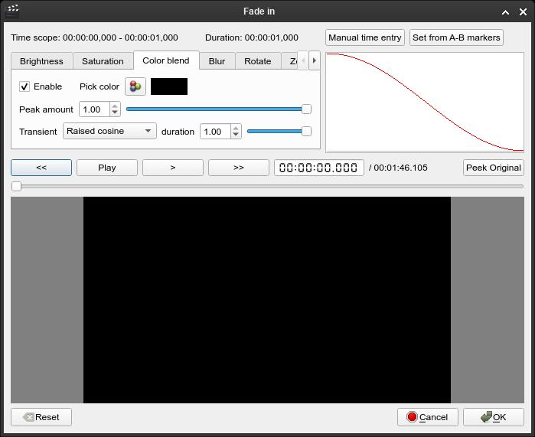](https://rs1.es/assets/imgs/avidemux-3.jpg)
* Color balance, contrast and brightness.
* Chroma key (replace a “green screen” with an image).
* And much more, all divided into categories.

You can add or remove audio tracks by clicking “Audio” at the top, and selecting “Select Track”.

[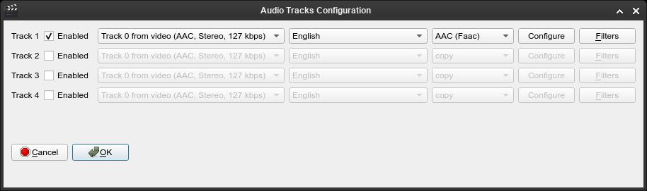](https://rs1.es/assets/imgs/avidemux-5.jpg)

# The “Configure” option

The “Configure” option under “Video Output” lets you to change video quality and processing speed. If you select “Use advanced configuration”, all tabs will be enabled, with a lot of options to fine-tune the encoding process.

[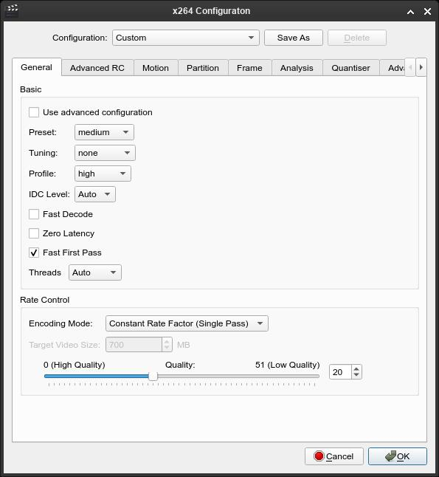](https://rs1.es/assets/imgs/avidemux-4.jpg)