|  |  |
| --- | --- |
| 1. **Itec/MODR 2915** | 1. Homework 1 [Link](http://oldtown.glendon.yorku.ca/~teaching/2023/itec2915/hw1/start/homework1_2915_start.docx) |
| 1. [Submission link](https://eclass.yorku.ca/mod/assign/view.php?id=1768069) |  |

1. **DUE: SUNDAY, OCTOBER 16 AT MIDNIGHT**
   * + - * Please submit a short report (PDF or WORD) with some brief explanations and links to your results (URLs).

I. Question 1: 70 points

1. (20 pts) Examine this URL:
2. <http://oldtown.glendon.yorku.ca/~teaching/2915/hw1/html/oldtown01.html>
3. (View 🡪 page source, to look at the source code.)
4. Then, make your own URL at:
5. <http://oldtown.glendon.yorku.ca/~yourlastname/2915/hw1/html/music01.html>
6. that looks and behaves exactly like this:
7. <https://politicalrights2022-1223.trinket.io/sites/question01-html>
8. (You cannot see the html source code above intentionally!)
9. (50 pts) Protect now your URL (above in A):
10. (30 pts)
11. <http://oldtown.glendon.yorku.ca/~yourlastname/2915/hw1/html/music01.html>
12. with 3 distinct usernames t1, t2, and t3. But the password should be the same. It is your student number.
13. **(20 pts)** Additionally make one username “sandy001” with the same password (sandy001) for your URL (a new one): http://oldtown.glendon.yorku.ca/~yourlastname/2915/hw1/html001/music01.html

**but with** your .htpasswd database at,

1. **/home/yourlastname/extra/security/.sandy/.htpasswd**
2. for extra security. For help, see [class recording](https://eclass.yorku.ca/mod/lesson/view.php?id=1768068).

II. Question 2: 30 points

1. (15 pts) Given this [WORD](http://oldtown.glendon.yorku.ca/~teaching/2023/itec2915/hw1/start/access_to_information_2915_justice01.docx) file.
2. Create your web site at:
3. **http://oldtown.glendon.yorku.ca/~yourlastname/2023/justice/blog01.html**
4. that looks and behave exactly just like this:
5. <http://oldtown.glendon.yorku.ca/~teaching/2023/justice/blog01.html>
6. (15 pts) Starting at your PATH **/home/yourlastname/www;**
7. Create a HIERARCHY that includes the following web directory organization:
8. 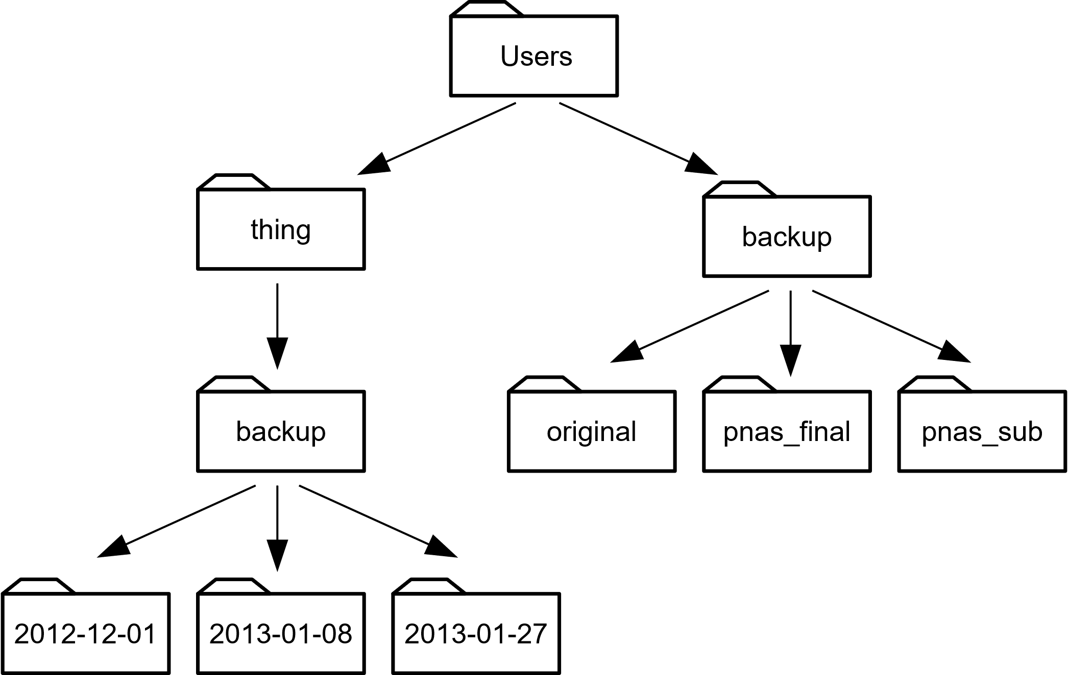

THE END