Itec/MODR 2915 EN
Fall 2020

Homework 1: Glendon working environment


Moodle: https://eclass.yorku.ca

Rstudio-server: https://oldtown.glendon.yorku.ca/
Username: yourlastname (always in small letters)
Password: your_student_number
Your web pages are at: http://oldtown.glendon.yorku.ca/~yourlastname

Exercise 1:

Login our server at: https://oldtown.glendon.yorku.ca/

Username: yourlastname (always in small letters)
Password: your_student_numbe

You will have this graphic below:

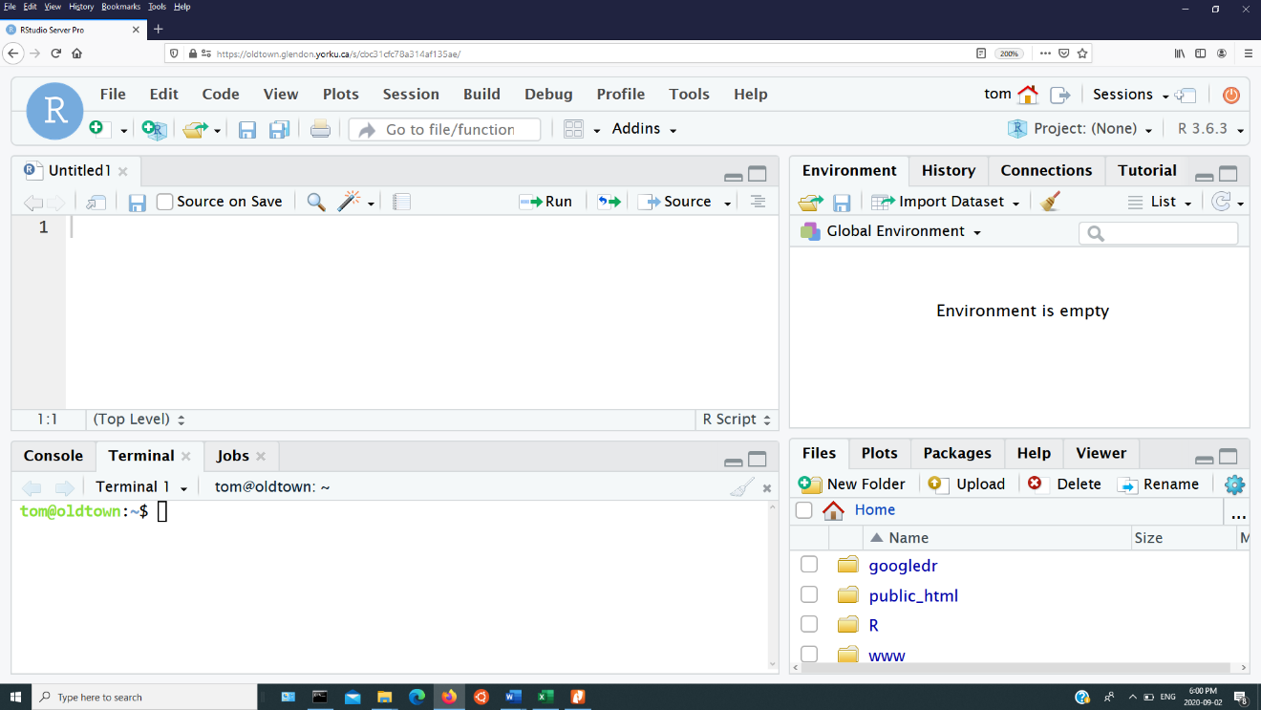

Upon completing this course, a student will be able to create responsive web pages and to:

- Work in the Glendon working environment (Client-server model) and rstudio-server pro
- Write web pages using html, css and JavaScript
- Communicate with classmates using multimedia tools; learn novel features of Office 365 such as transcribe and recording.
- Collaborate with classmates using social networking and collaboration tools including Office 365.
- To understand examples of a relational database
- Implement Web security with htpasswd, and htaccess

Attendance:

Attendance is mandatory however I realize there are times when you must be absent. Please give me an advance notice of any absences.

Grading:

Homework 40%
1 Test 20%
Final 40%
All Assignments will be submitted through our Moodle web site. If you have multiple files, please zip all your files and label it, for example: “yourname_Assignment1.zip”

Collaboration:
- I encourage you all to work together through problems – make sure you comment who you have worked with at the top of the page of your submission

Class Etiquette:
- Be respectful to your fellow classmates.
- Email me anytime if you have a question.

Tentative Schedule:

Week | Topic | Notes
1 | Glendon working environment and rstudio-server
2 | Overview of HTML, and CSS | Homework 1
3 | Overview of HTML, CSS, and JavaScript
4 | Collaborate with classmates using social networking and collaboration tools | Homework 1 due
5 | Communicate with classmates using multimedia tools; Information search; novel features of Office 365 such as transcribe and recording; image, video, and sound; animation
6 | Review | Homework 2
7 | Design and implementation of a relational database I | Test
8 | Design and implementation of a relational database II | Homework 2 due
9 | Examples of DBMS; Excel and CSV
10 | Review and practice
11 | Wrapping it all up

