1. **Itec/MODR 2915**
2. Homework 1
3. [Submission link](https://eclass.yorku.ca/mod/assign/view.php?id=1768069)  [Link to homework 1](http://oldtown.glendon.yorku.ca/~teaching/2023/itec2915/hw1/start/homework1_2915_start.docx)
4. **DUE: SUNDAY, OCTOBER 15 AT MIDNIGHT**

I. Question 1:

1. Examine this URL:
2. [http://oldtown.glendon.yorku.ca/~teaching/2915/hw1/html/oldtown01.html](http://oldtown.glendon.yorku.ca/~teaching/2915/hw1/html/oldtown01.html%20%09)
3. (View→ page source to look at the source code.)
4. Then, make your own URL at:
5. <http://oldtown.glendon.yorku.ca/~yourlastname/2915/hw1/html/music01.html>
6. that looks and behaves exactly like this:
7. <https://politicalrights2022-1223.trinket.io/sites/question01-html>
8. (You cannot see the html source code above intentionally!)
9. Protect now your URL (above in A):
10. <http://oldtown.glendon.yorku.ca/~yourlastname/2915/hw1/html/music01.html>
11. with 3 distinct usernames t1, t2, and t3. But the password should be the same. It is your student number.

If you can, try additionally to keep your .htpasswd database at,

1. **/home/yourlastname/extra/security/.sandy/.htpasswd**
2. for extra security. For help, see [class recording 002.](https://eclass.yorku.ca/mod/lesson/view.php?id=1768068)

II. Question 2:

1. Given this [WORD](http://oldtown.glendon.yorku.ca/~teaching/2023/itec2915/hw1/start/access_to_information_2915_justice01.docx) file.
2. Create your web site at:
3. **http://oldtown.glendon.yorku.ca/~yourlastname/2023/justice/blog01.html**
4. that looks and behave exactly just like this:
5. <http://oldtown.glendon.yorku.ca/~teaching/2023/justice/blog01.html>
6. Starting at your PATH **/home/yourlastname/www;**
7. Create a HIERARCHY that includes the following web directory organization:
8. 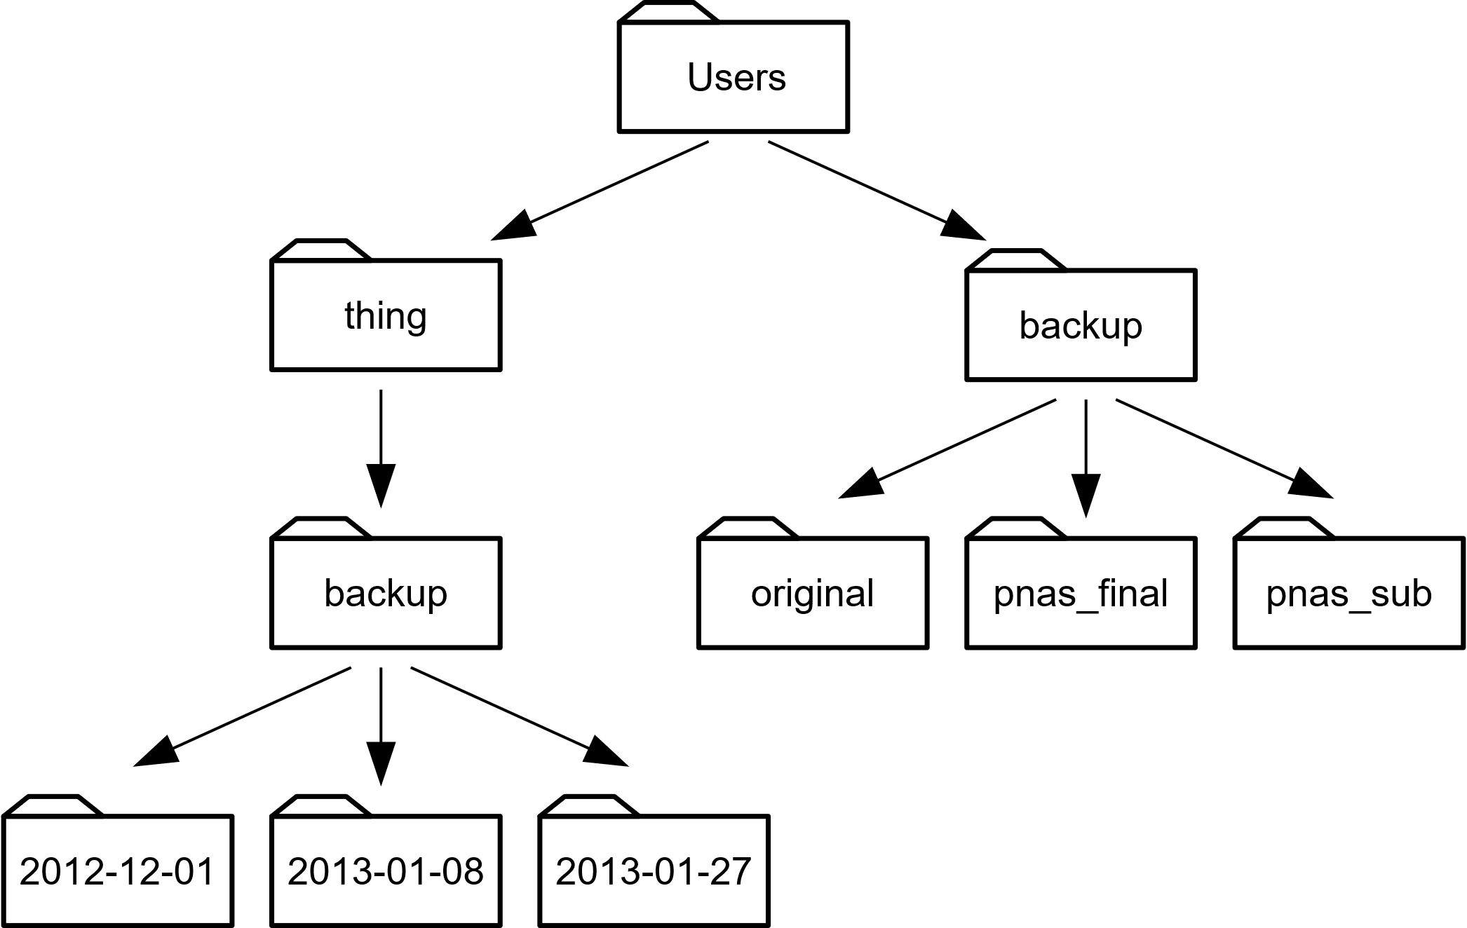

THE END