# HTML and CSS Overview

## My First Page

Create a Web Page like the following.

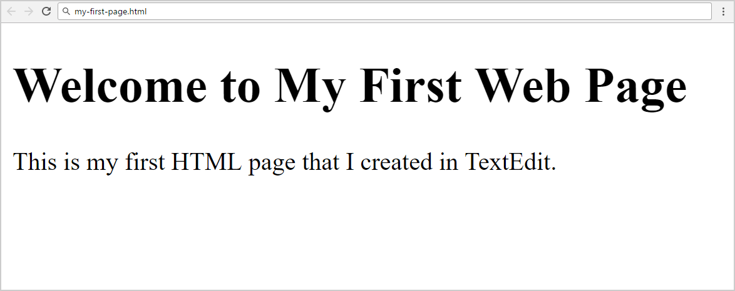

Create “**my-first-page.html**”

### Constraints

* <h1> tag for heading
* <p>tag for paragraph

## Definition Lists

Create a Web Page like the following.

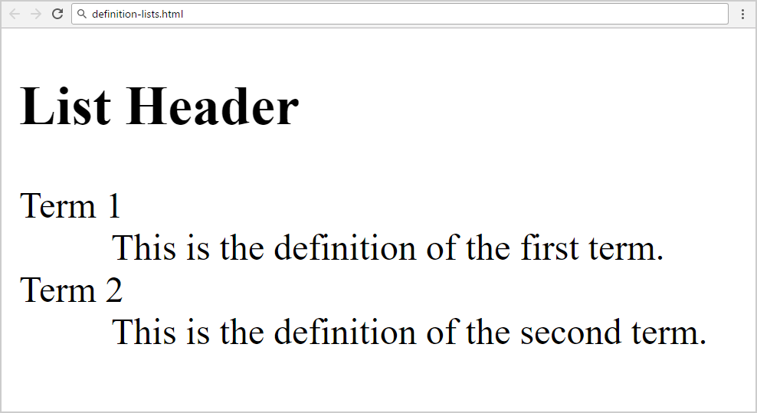

Create “**definition-lists.html**”.

### Constraints

* <h2> tag for heading
* <dl>tag for definition list

## Reversed List

Create a Web Page like the following.

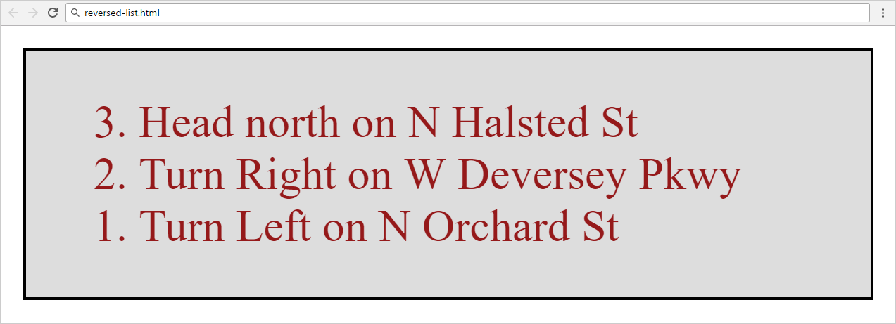

Create two files: “**reversed-list.html**”and“**reversed-list.css**”.

### Constraints

* <div>with **id=wrapper** as a **container**
  + Background color: #dddddd
  + Text color: #95191a
  + Width container: 300px
  + Border: 1px solid #000000

### Hints

Use:

* <ol> with **reversed** attribute
  + <ol reversed="reversed">
* Submit **only** **reversed-list.html** + **reversed-list.css** in **ZIP** file

## My Second Page